SERVICE CLUB WEEK 2024

OCTOBER

The Service Clubs Association of South Australia Inc.
invites all South Australian Service Clubs to:-

- Nominate for the Environmental award with the Community

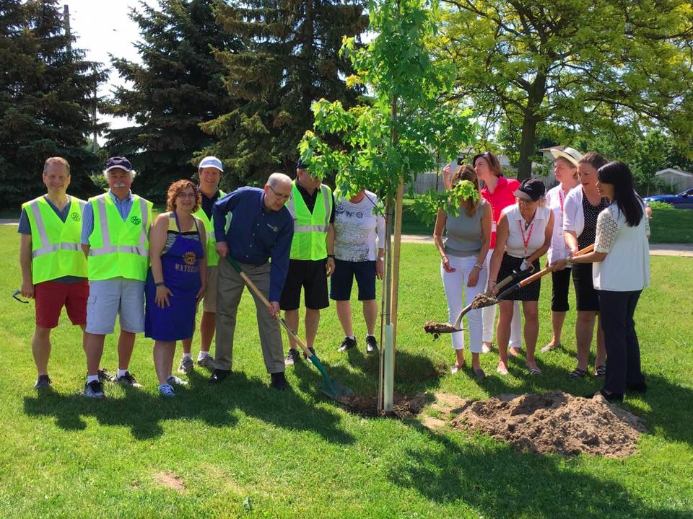
- Attend the Premier’s Awards Presentation Luncheon, to be held on Sunday, 23rd February 2025 from noon (venue to be confirmed)

- Celebrate Service Club Week, in October by holding a Joint Club Event.

Prizes are made available by a grant from the Premier’s Community Service Awards 2024.

Please visit the website for more information: http://scasa.org.au/

Environmental award with the Community
Nomination Form

This award recognises Environmental work with the community, which has established a fauna and flora protection and/or rehabilitation/recycling activities initiated with the community.
Creating environments with educational initiatives and awareness programs relating to sustainability has positive outcomes for your organisation and the community.

In your nomination describe the community’s contribution and the improvement of environment outcomes. This could include a reduction in energy and water consumption, improved waste management, improved living conditions and accessibility, enhanced biodiversity etc.

If you are able to include an educational component, describe the outcomes for the community and or within schools or other educational institutions.

All nominations must be received no later than Close of Business on 31st October 2024

Please provide FULL and ACCURATE Club Information

Name of Submitting Club:

ABN:

Postal Address:

Email:

President’s Name:

Name of Contact Person:

Contact Phone No:

Name and Contact Details of Nominee:
Name:

Postal Address:

Email: Phone:
Name of Bank Account:
BSB Number
Account Number

Details of Environmental work with the community:

Please attach a brief summary (no more than 500 words) giving specific details of the nominee’s service to the community.

Completed nomination forms should be emailed to

Peter Zander SCASA at applications@scasa.org.au

or by post to SCASA Nomination C\- PO Box 123, Park Holme SA 5043

